

**USER GUIDE**

**JAVA FLORIST**

|  |  |  |
| --- | --- | --- |
| **Supervisor:** | *NGUYEN NGO PHUOC* | |
| **Semester:** | *3* | |
| **Batch No:** | *T1.1908.E0* | |
| **Group No:** | *02* | |
| **Order:** | **Full name** | **Roll No.** |
| *1.* | *Duong Ngoc Hai* | Student1198484 |
| *2.* | *Nguyen Hien Long* | Student1198731 |
| *3.* | *Nguyen Xuan Phong* | Student1198583 |
| *4.* | *Le Tuan Khang* | Student1204495 |

***Month****: 01* ***Year****: 2021*

# TABLE OF CONTENTS

TABLE OF FIGURE ii

I. USER PAGE 1

1. Header 1

2. Footer 2

3. Home page 3

4. Contact us page 4

5. Product Page 5

6. Product details page 6

7. Login Page 7

8. Register Page 9

9. Profile Page 10

10. Edit information page 11

11. Change Password 12

12. Change Avatar Page 13

13. Cart page 14

14. Checkout page 15

15. User order manager page 16

Admin pages Error! Bookmark not defined.

1. Dashboard 17

2. Product 18

3. Category 20

4. List User 21

5. Message 21

6. Feedback 22

7. Order 23

# TABLE OF FIGURE

Figure 1. Header before login 1

Figure 2. Header after login 1

Figure 3. Footer 2

Figure 4. Homepage #1 3

Figure 5. Homepage #2 3

Figure 6. Product page 5

Figure 7. Product detail page 6

Figure 8. Login Page 7

Figure 9. Register Page 9

Figure 10. Profile Page 10

Figure 11. Edit Profile Page 11

Figure 12. Change password page 12

Figure 13. Change avater page 13

Figure 14. Cart page 14

Figure 15. Checkout page 15

Figure 16. User order manager page 16

Figure 17. Admin DashBoard 17

Figure 18. Product managerment page 18

Figure 19. Add and edit image popup 19

Figure 20. Category managerment page - admin 20

Figure 21. Feedback list 22

Figure 22. Feedback details 22

Figure 23. Order list 23

I. User page

# Header

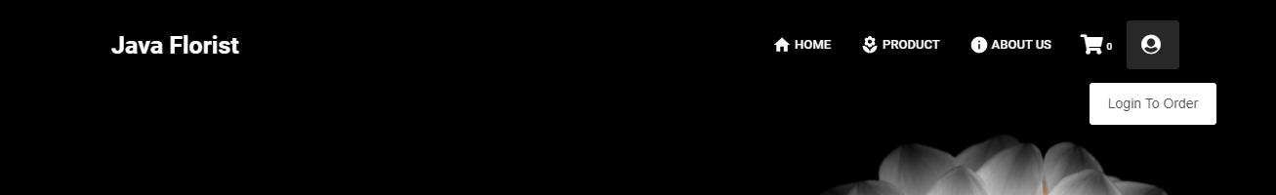

1. Header before login

This section is called Header, which is always on top of all pages, Header section includes:

* Website name: users can return to the homepage at any time by clicking on this logo.
* The titles of the component pages:
* Home
* About us & contact
* Product
* Cartpage
* Login/Register button

After the user login, the Header will turn into the image below:

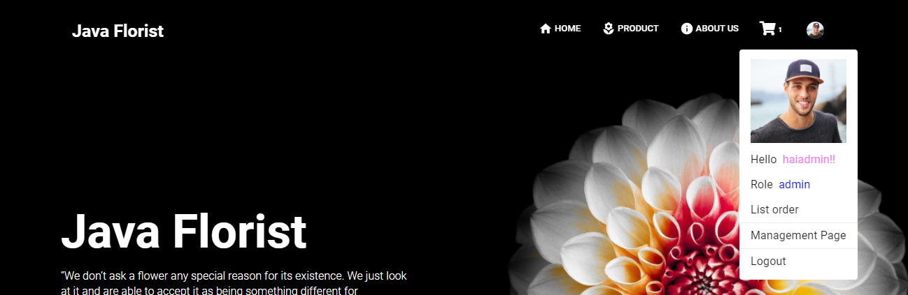

1. Header after login

* Login icon will be replaced by the profile card
* Profile Card have user’s UserName, link to their order, link to their Profile Page and logout button.

# Footer



1. Footer

This section is called Footer, which is always at the end of all pages, Footer section includes brand name and some information and communication channels of website.

# Home page

**Home page includes**

* Introduce part
* Product image
* Basic information

1. Homepage #1

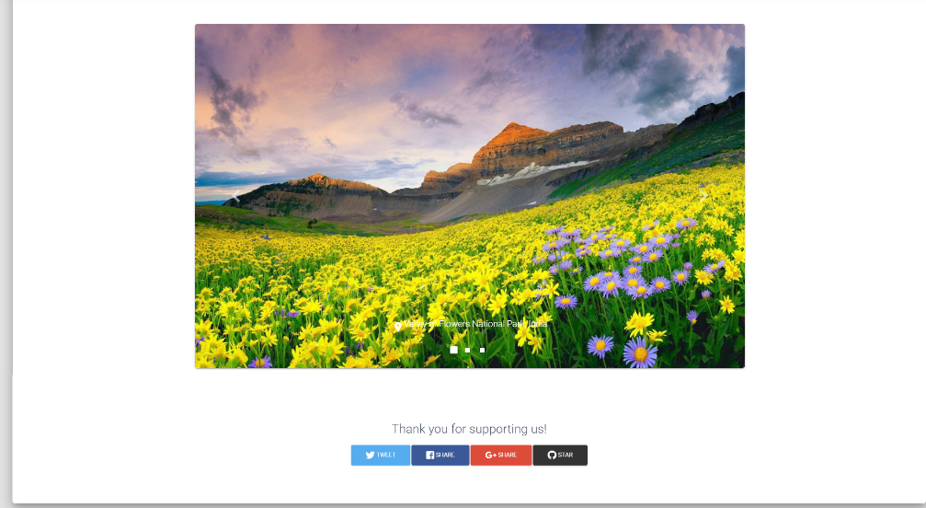

1. Homepage #2

# Contact us page

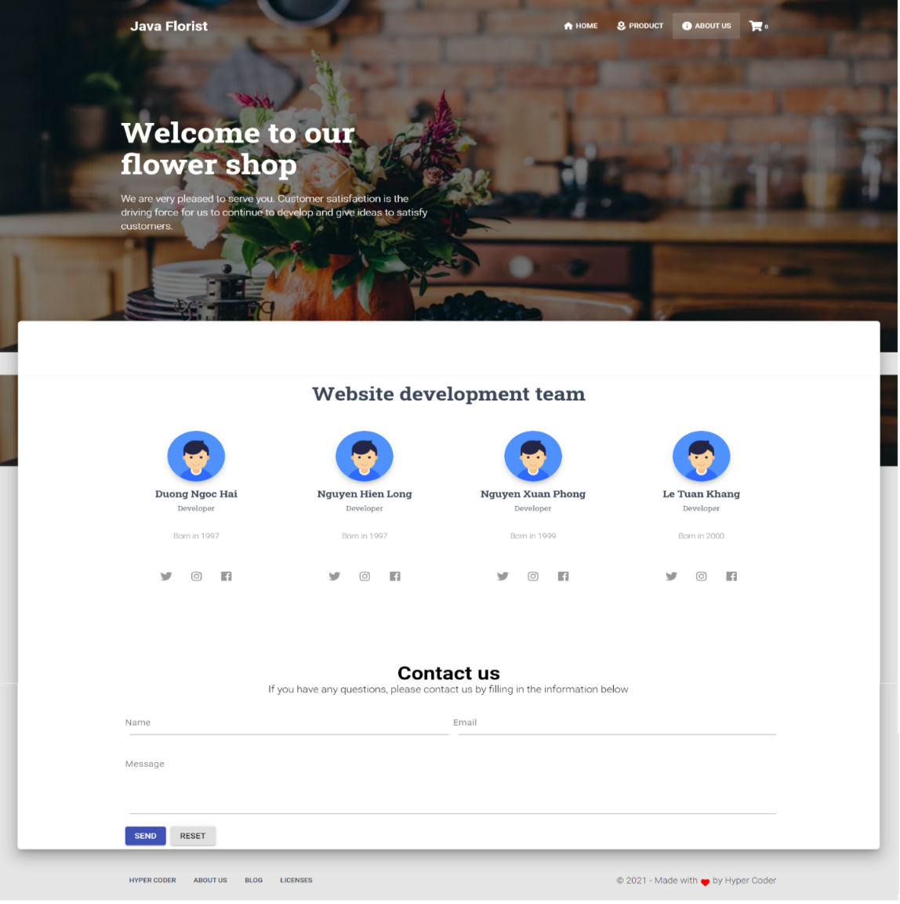

In Contact Us page, users can contact back to the website or problems related to the product. Note: the feedback form must be entered according to the following rule:

|  |  |
| --- | --- |
| **Name of the data field** | **Rule** |
| Email | Required to enter up to 255 standard characters and must in email format |
| Name | Required to enter up to 255 characters |
| Message | Required to enter up to 8000 characters |

# Product Page

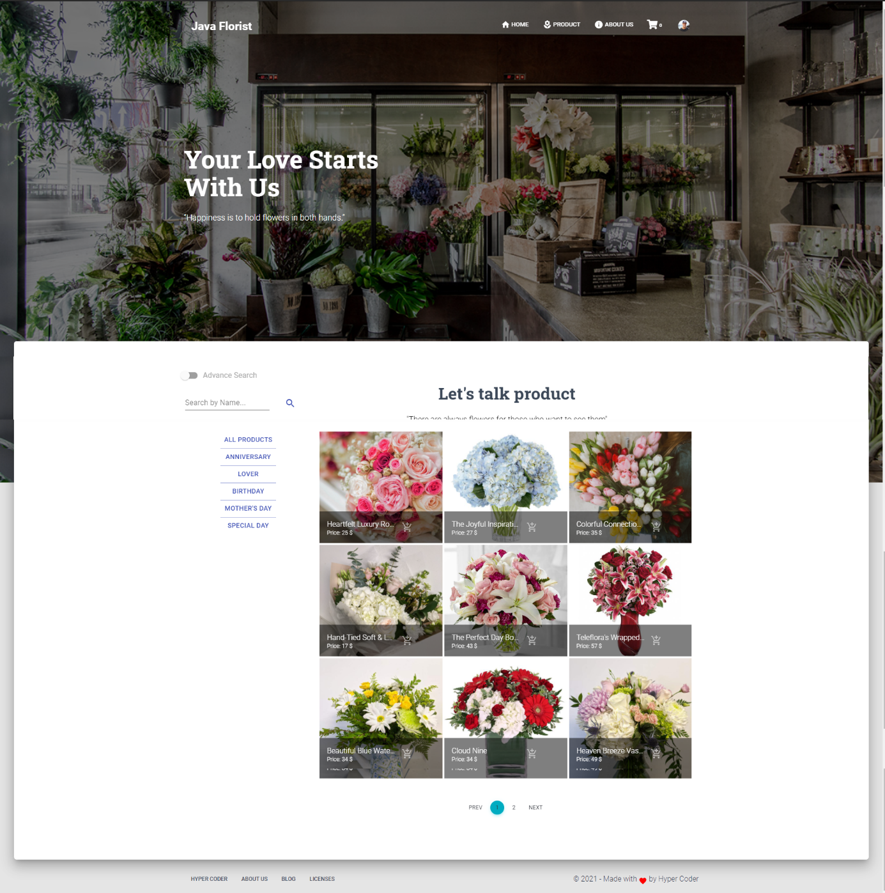

1. Product page

**Product Page** includes:

* Background image of the shop
* Product List: List of products for customers to choose, customers can search for products on this page, there is a menu on the left that allows users to filter by name, category, price, …
* After that they can add product to cart by the button in each product

While on this page, if the user clicks on the name of the product, they will be redirected to the product details page.

# Product details page

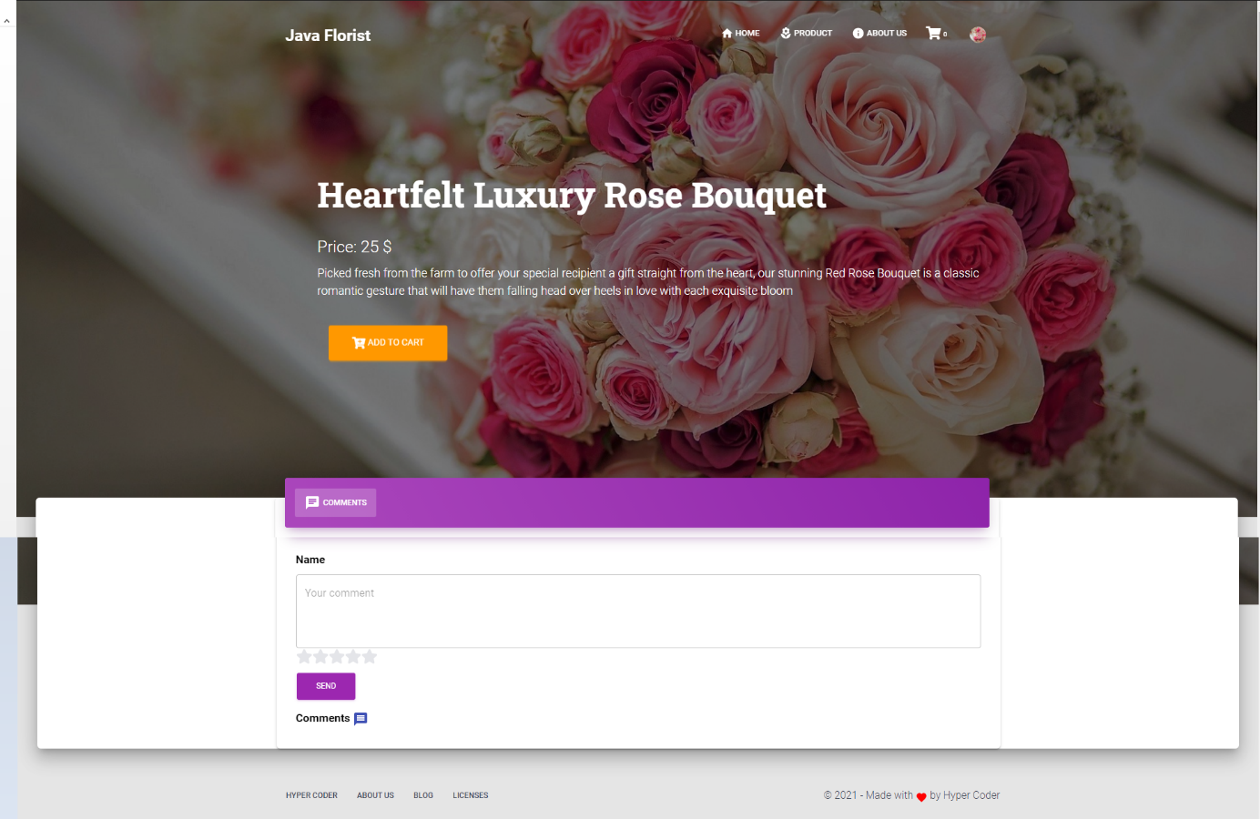

1. Product detail page

**Product details page** includes:

* Fullscreen picture of product
* Product description
* They can also comment on the product by the form below

Comment are used to rate the product on this page, to submit users are required to enter comments and star reviews for the product

|  |  |
| --- | --- |
| **Name of the data field** | **Input rules** |
| Comment | Required to enter up to 8000 characters |
| Rating | Required to click value |

# Login Page

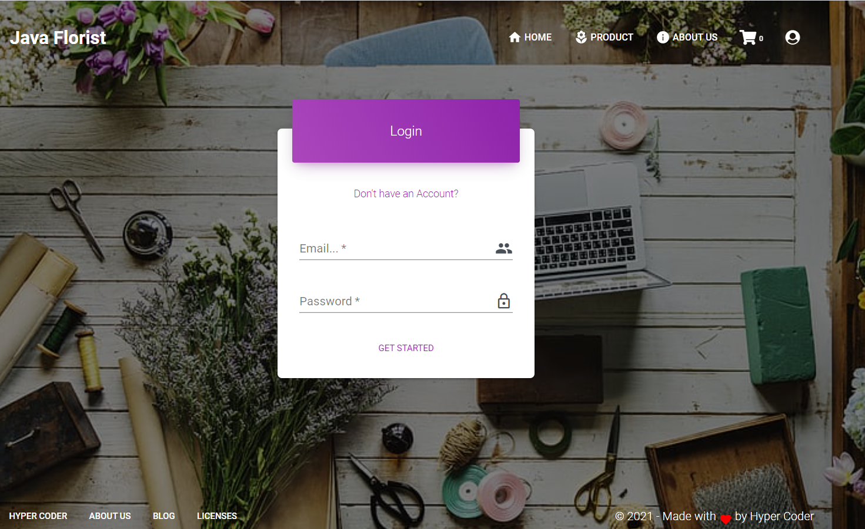

1. Login Page

**Route:** Login page can access from Header Link. In User page, user could get in to page by fill field “Email” and “Password” (Incase they have an account). If “Email” and “Password” correct, system will arlert for successful login and go back to home page. Even if user close web, in their next visit time they don’t need to login again, until they log out.

Attention: User have to follow these rules.

|  |  |
| --- | --- |
| **Field Name** | **Rules** |
| Email | Required and have to correct with email they have register |
| Password | Required |

* Login Page errors when not follow the rule

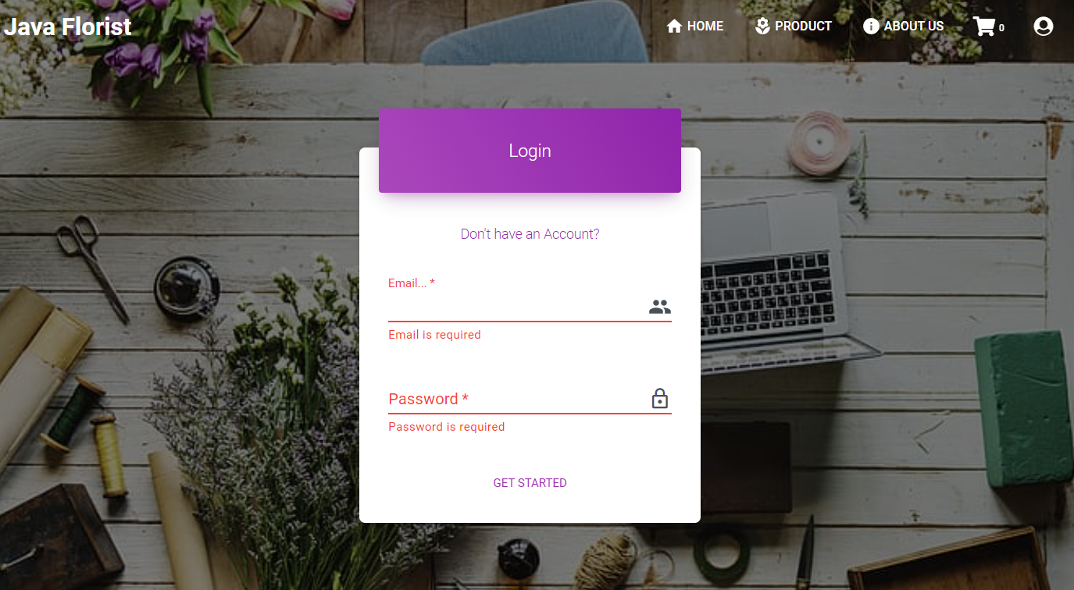

# Register Page

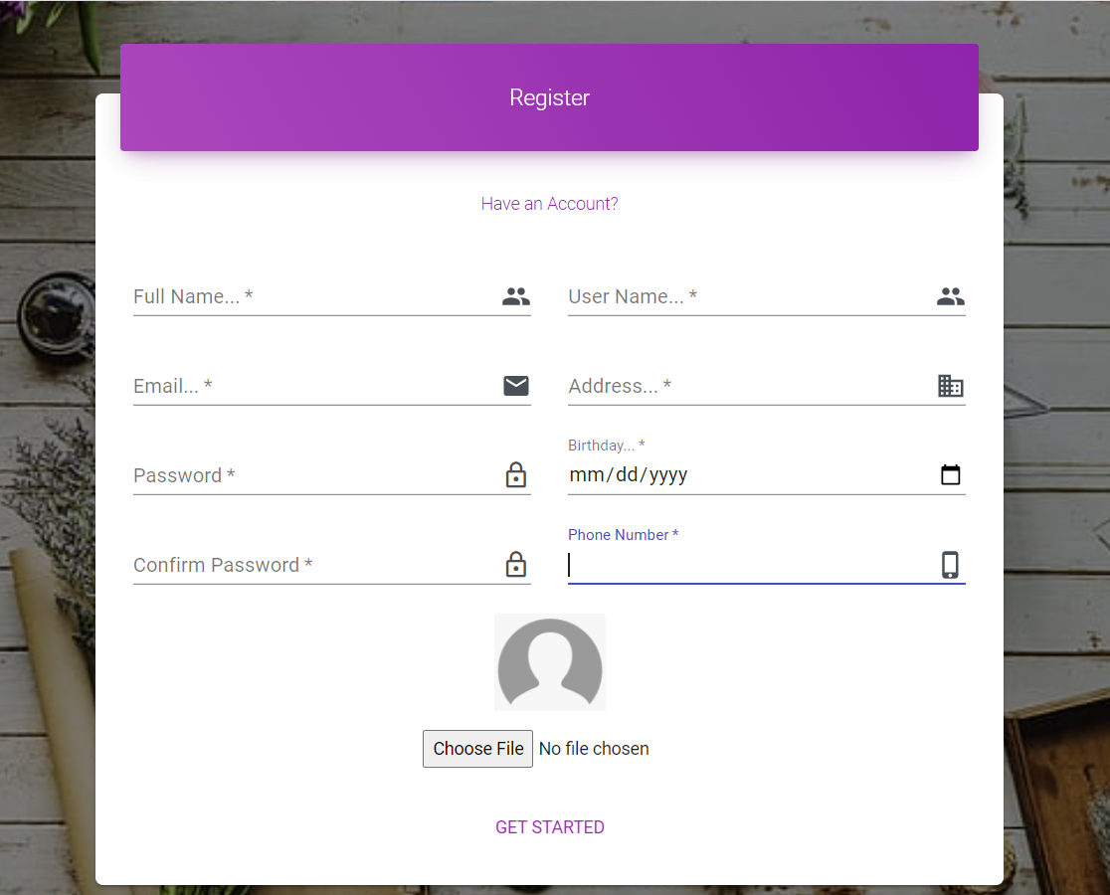

1. Register Page

**Register page** (Register), user could create a new account to order product on JavaFlorist. When user fill all of field, they could enter “GET STARTED” to create their new account

Attention: User have to follow these rules:

|  |  |
| --- | --- |
| **Field Name** | **Rules** |
| Fullname | Required |
| Username | Required |
| Email | Required & follow email format |
| Address | Required |
| Password | Required & atleast have 8 values |
| Confirm Password | Required & same with password |
| Birthday | Required |
| PhoneNumber | Required & In range 10-13 |

# Profile Page

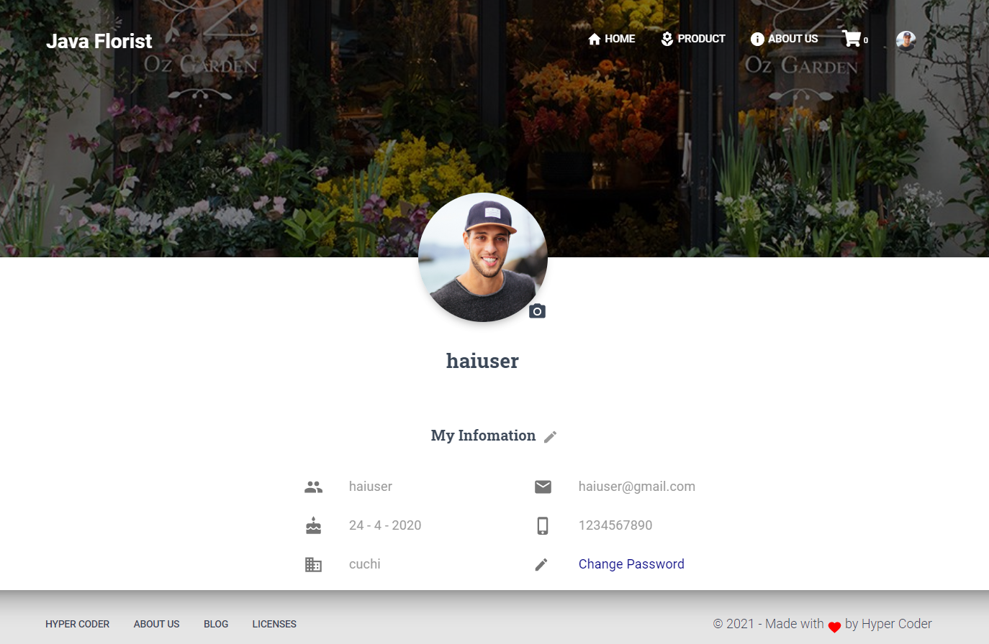

1. Profile Page

**Profile Page**: Display user infomation , to get into this page user have to create account and login, and go to this page through the profile management link in profile card.

# Edit information page

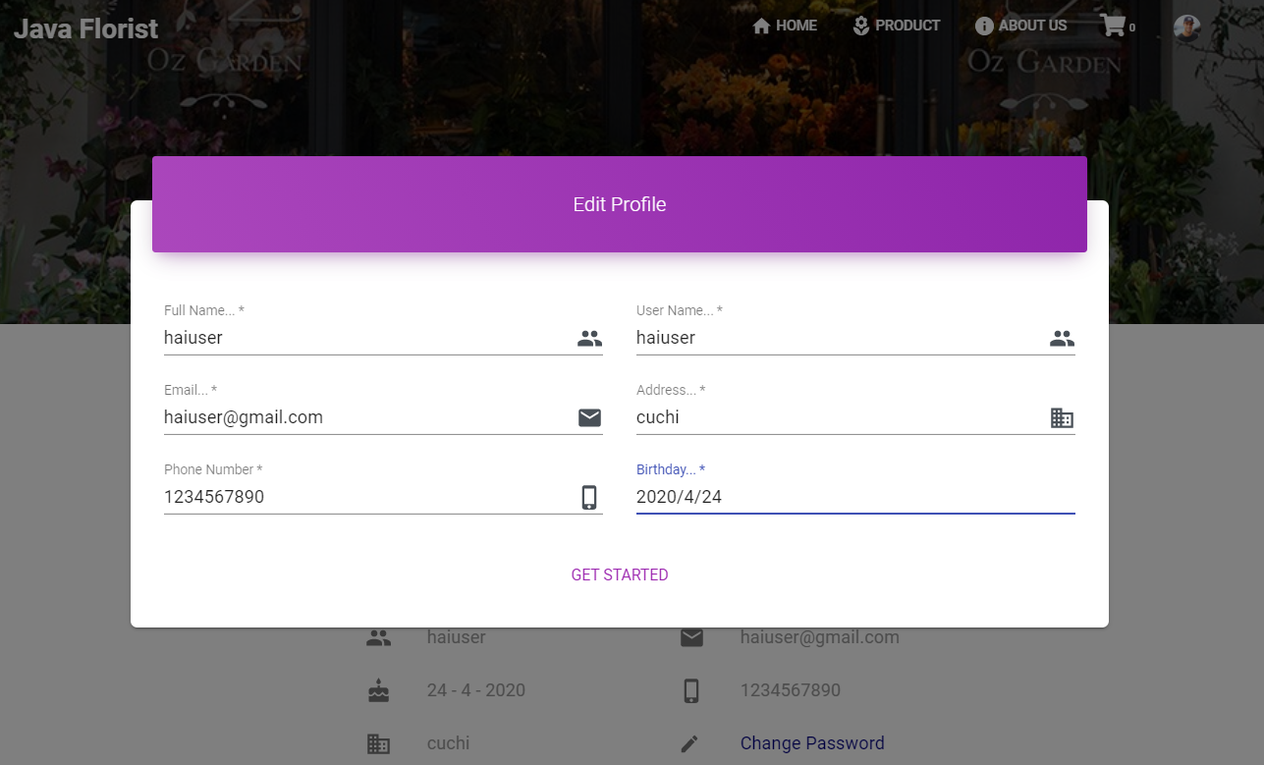

1. Edit Profile Page

Access to this by click the pencile incon next to “My Infomation” this page to Edit User’s Full Name, User Name, Email, Address, Birthday, PhoneNumber.

Attention: User have to follow these rules:

|  |  |
| --- | --- |
| **Field Name** | **Rules** |
| Email | Have to unique if they change |
| PhoneNumber | Have to in range 10-13 values if they change |

# Change Password

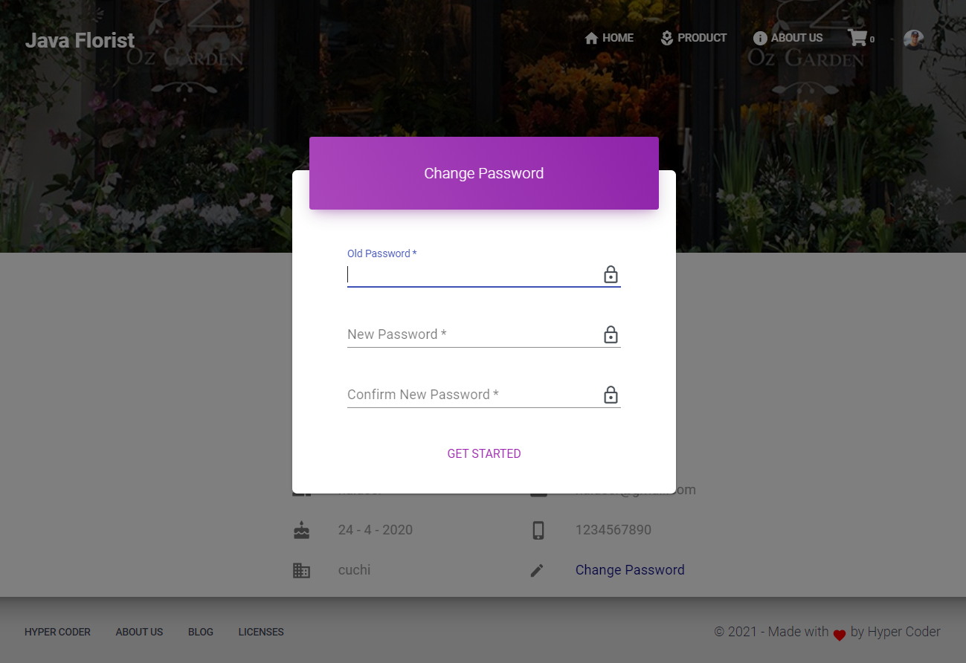

1. Change password page

Change Password Page: Access by clink Change Password link. User can change their password here.

Attention: User have to follow these rules:

|  |  |
| --- | --- |
| **Field Name** | **Rules** |
| Old Password | Required & Have to correct with their curent password |
| New Password | Required & At least 8 values |
| Confirm New Password | Required & correct with New Password |

# Change Avatar Page

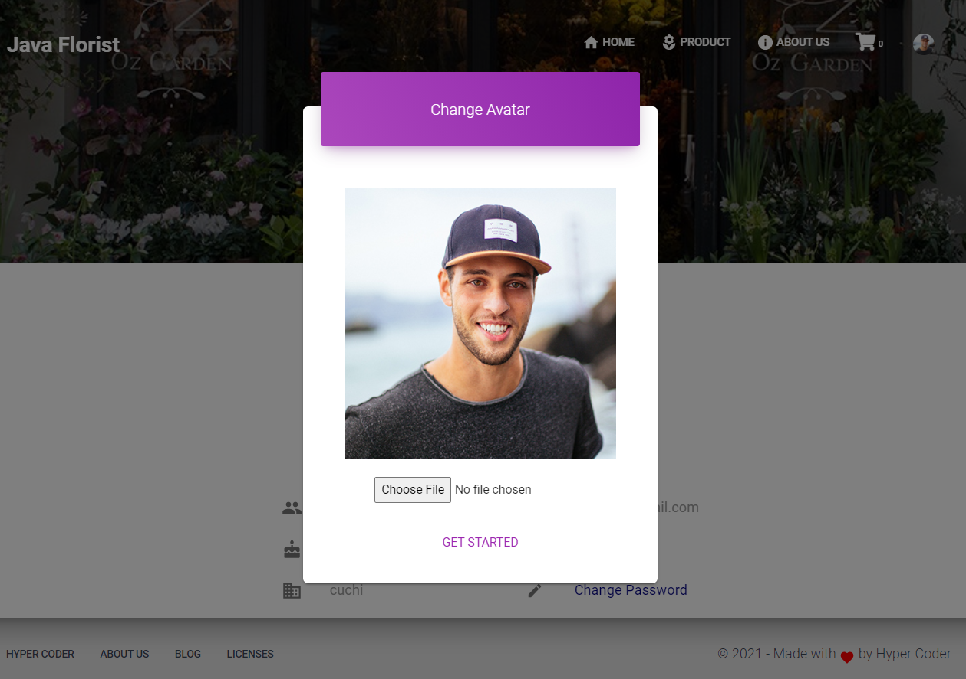

1. Change avater page

Change Avatar Page: Access by clink incon Camera next to user avatar. User can change their avatar here.

# Cart page

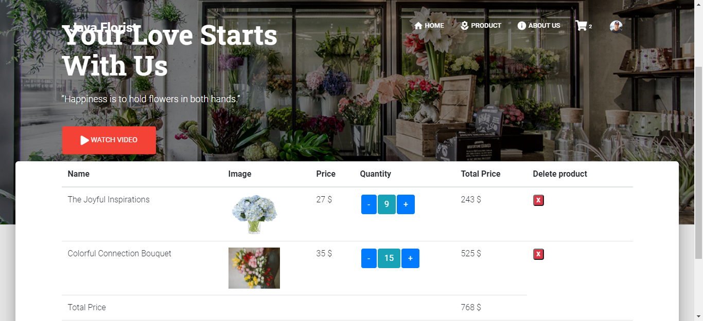

1. Cart page

**Product details page** includes:

The products in the shopping cart are added from the products page. The shopping cart page can add or remove products

# Checkout page

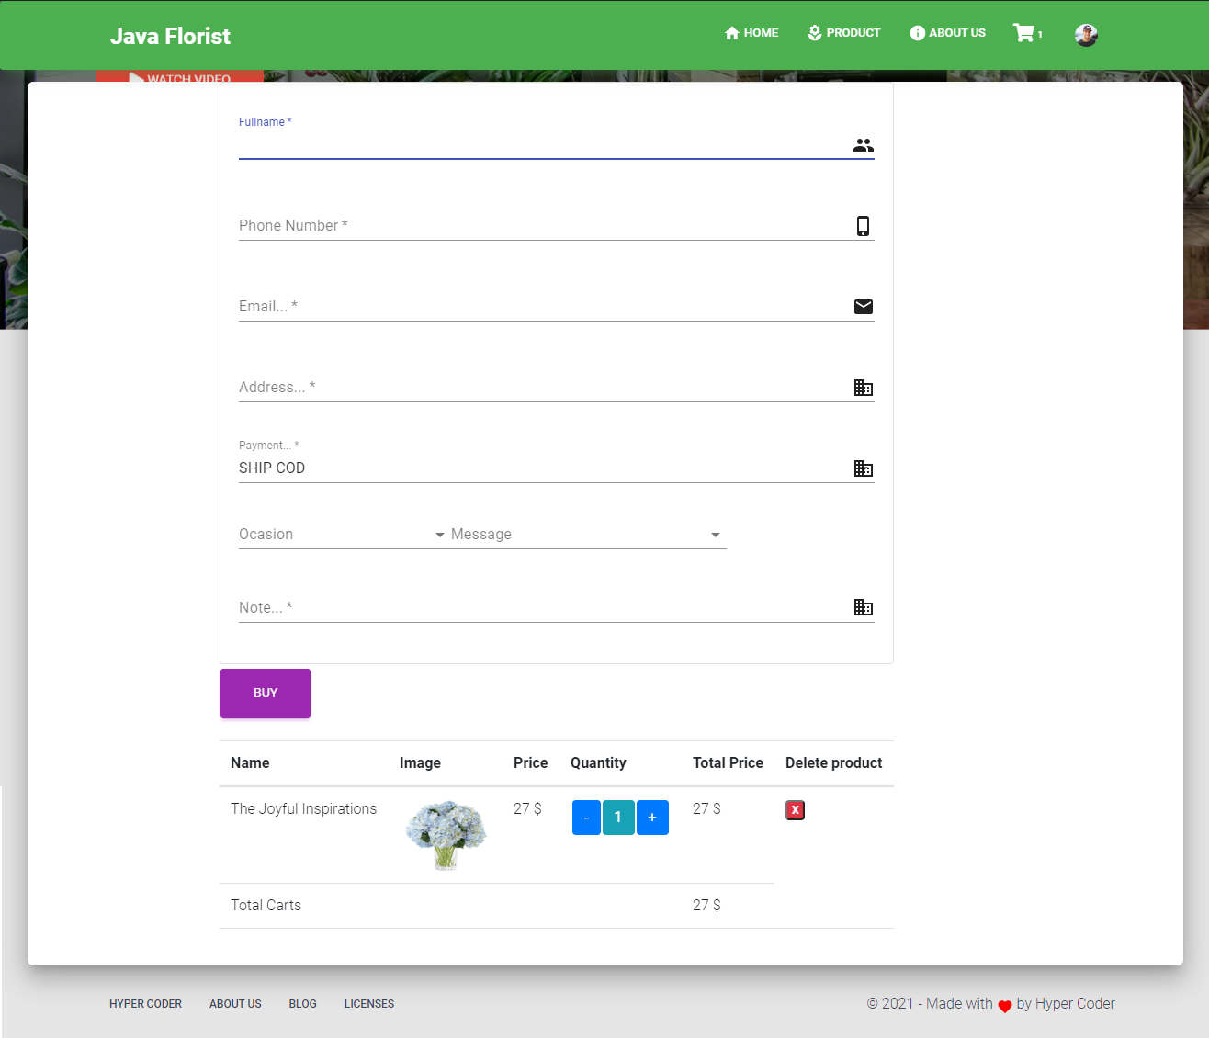

1. Checkout page

**Check Out**: On the Check Out, you can view the product you intend to buy and fill in the delivery information and delivery form.When you have enough information, click Order, the product will be saved and go to the Order List.

Note: User must fill in the fields above according to the following rule:

|  |  |
| --- | --- |
| **Field** | **Rules** |
| Full Name | Required |
| Phone | Required, number range 10 to 13 |
| Email | Required, Email format |
| Address | Required |
| Note | Required maximun 255 characters |
| Birthday | Required |

# User order manager page

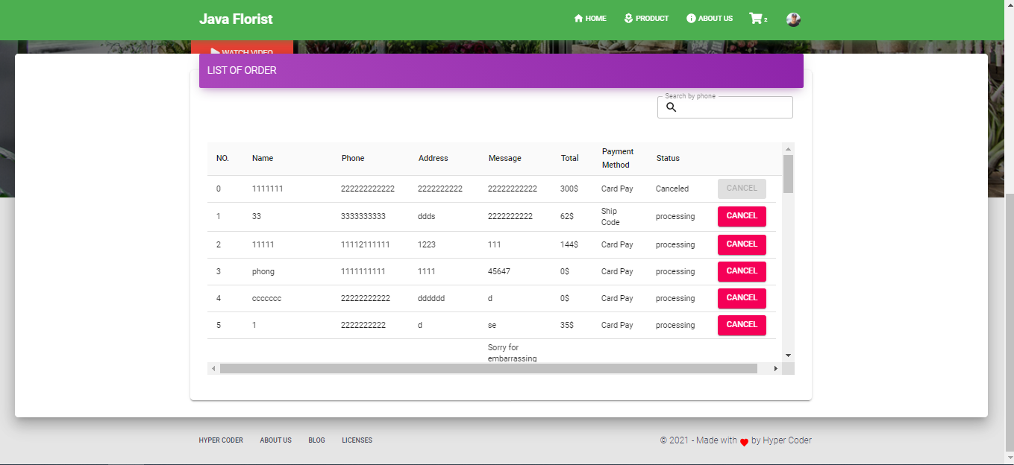

1. User order manager page

User can view order and cancel them if they is in processing status

II. ADMIN pages

# Dashboard

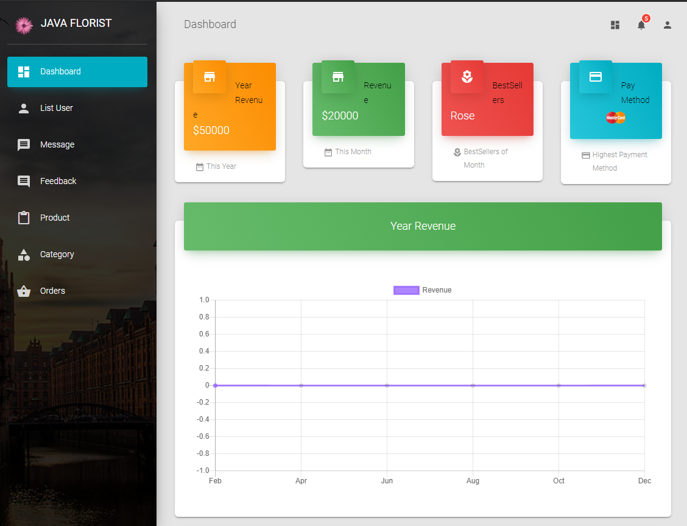

1. Admin DashBoard

Dashboard contains some statistic with side bar to move to other pages

# Product

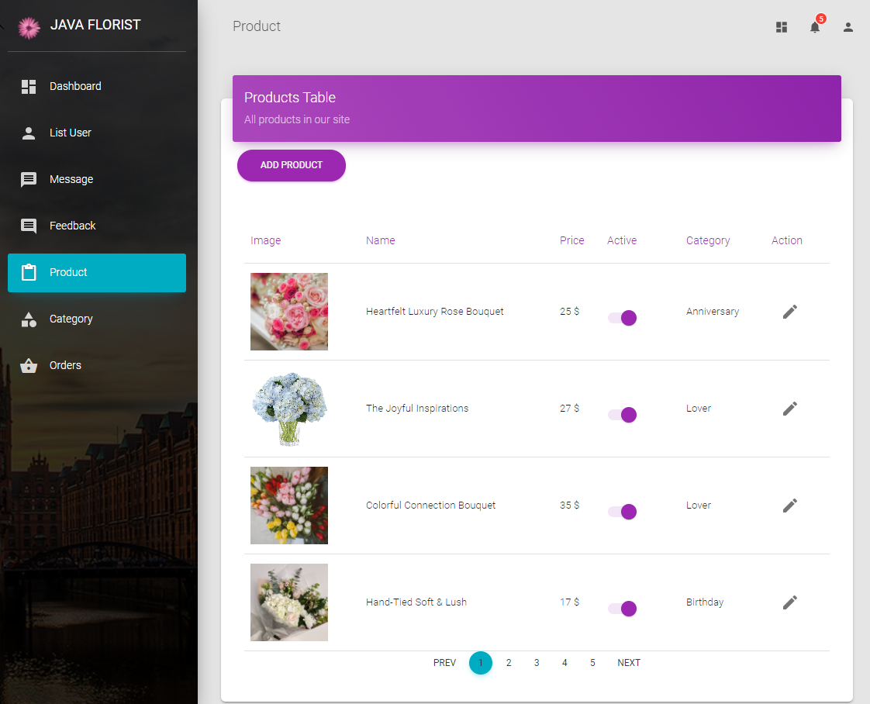

1. Product managerment page

**Purpose**: for admin to manage product list: view, view details, edit product.

Press add product button new popup will show, if click the pen icon on the right sight, the edit popup will show .

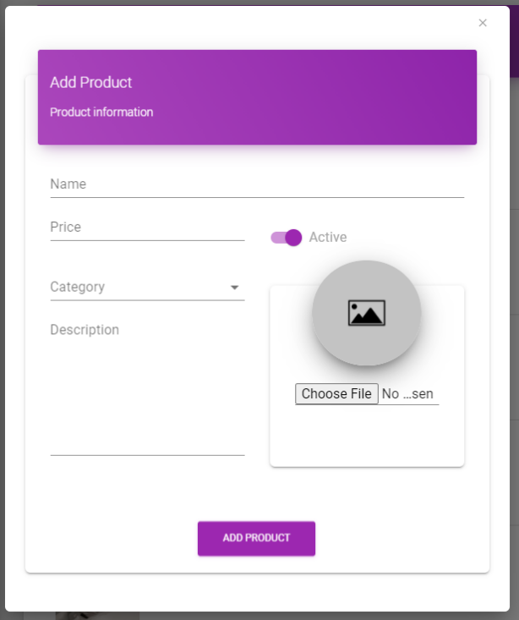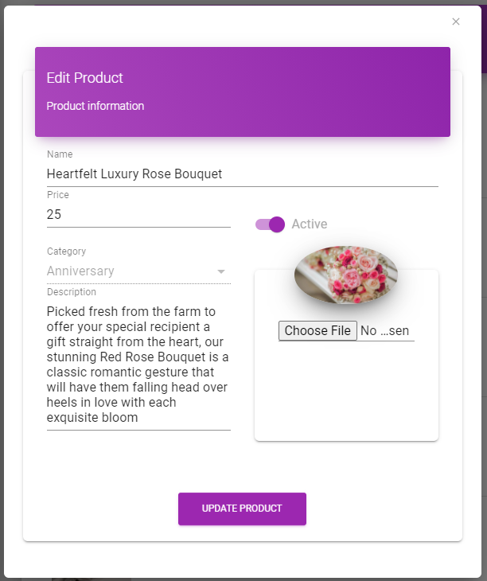

1. Add and edit image popup

|  |  |
| --- | --- |
| **Field name** | **Rule** |
| Name | Required to enter up to 255 standard characters and must in email format |
| Price | Required, must be positive |
| Category | Required, must be selected from available category |
| Active | Default is active |
| Description | Nullable, up to 8000 characters |
| Image | Required, must in image format (jpg, png,…) |

# Category

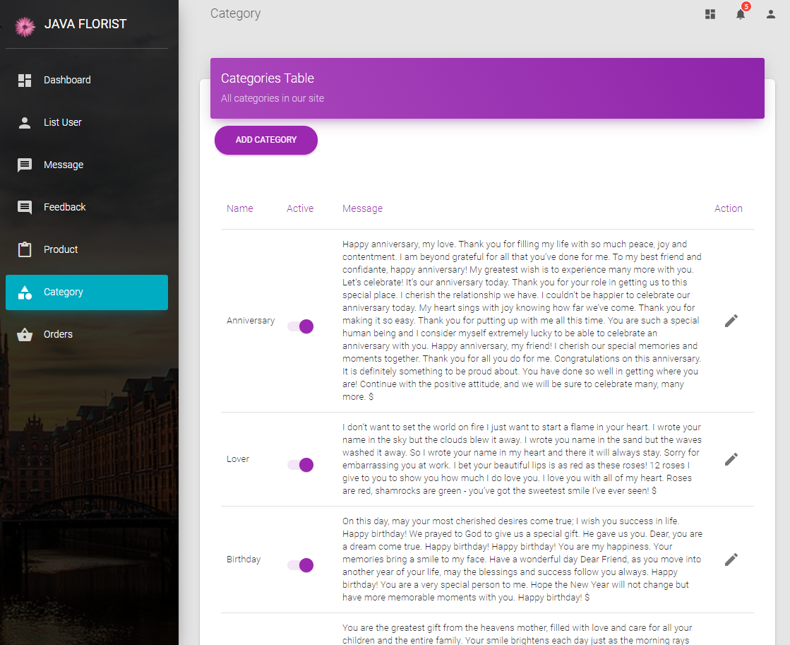

1. Category managerment page - admin

**Purpose**: for admin to manage product list: view, view details, edit product.

Press add product button new popup will show, if click the pen icon on the right sight, the edit popup will show. (same as product)

|  |  |
| --- | --- |
| **Field name** | **Rule** |
| Name | Required to enter up to 255 standard characters and must in email format |
| Price | Required, must be positive |
| Active | Default is active |
| Message | Required, up to 8000 characters |

# List User

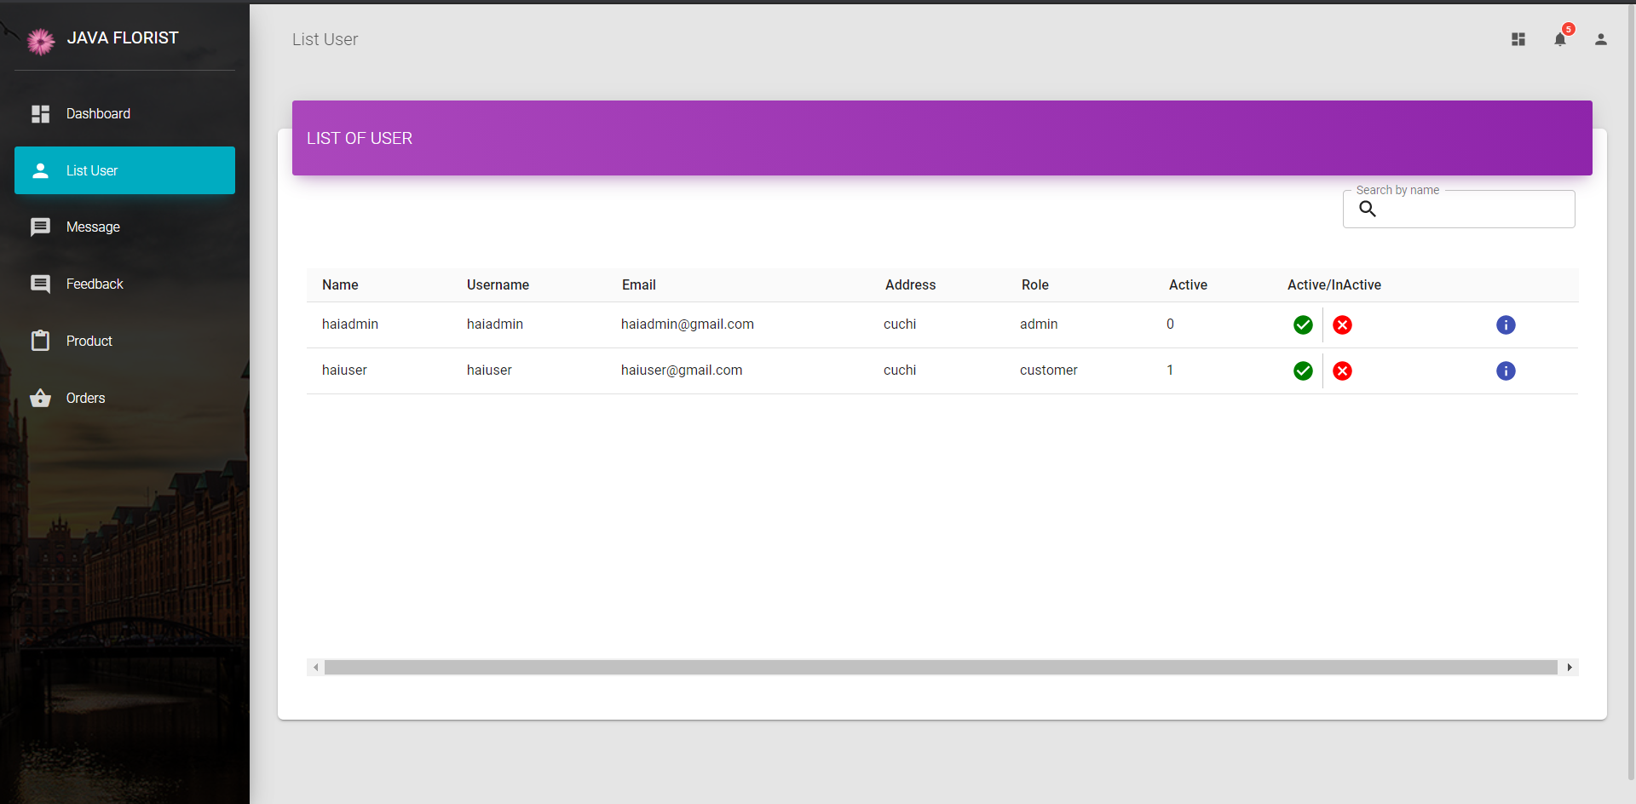

List User, the administrator can manage viewing customer information on this page and can change the active status for customers here.

The admin cant search for user by the input in the right-top corner

# Message

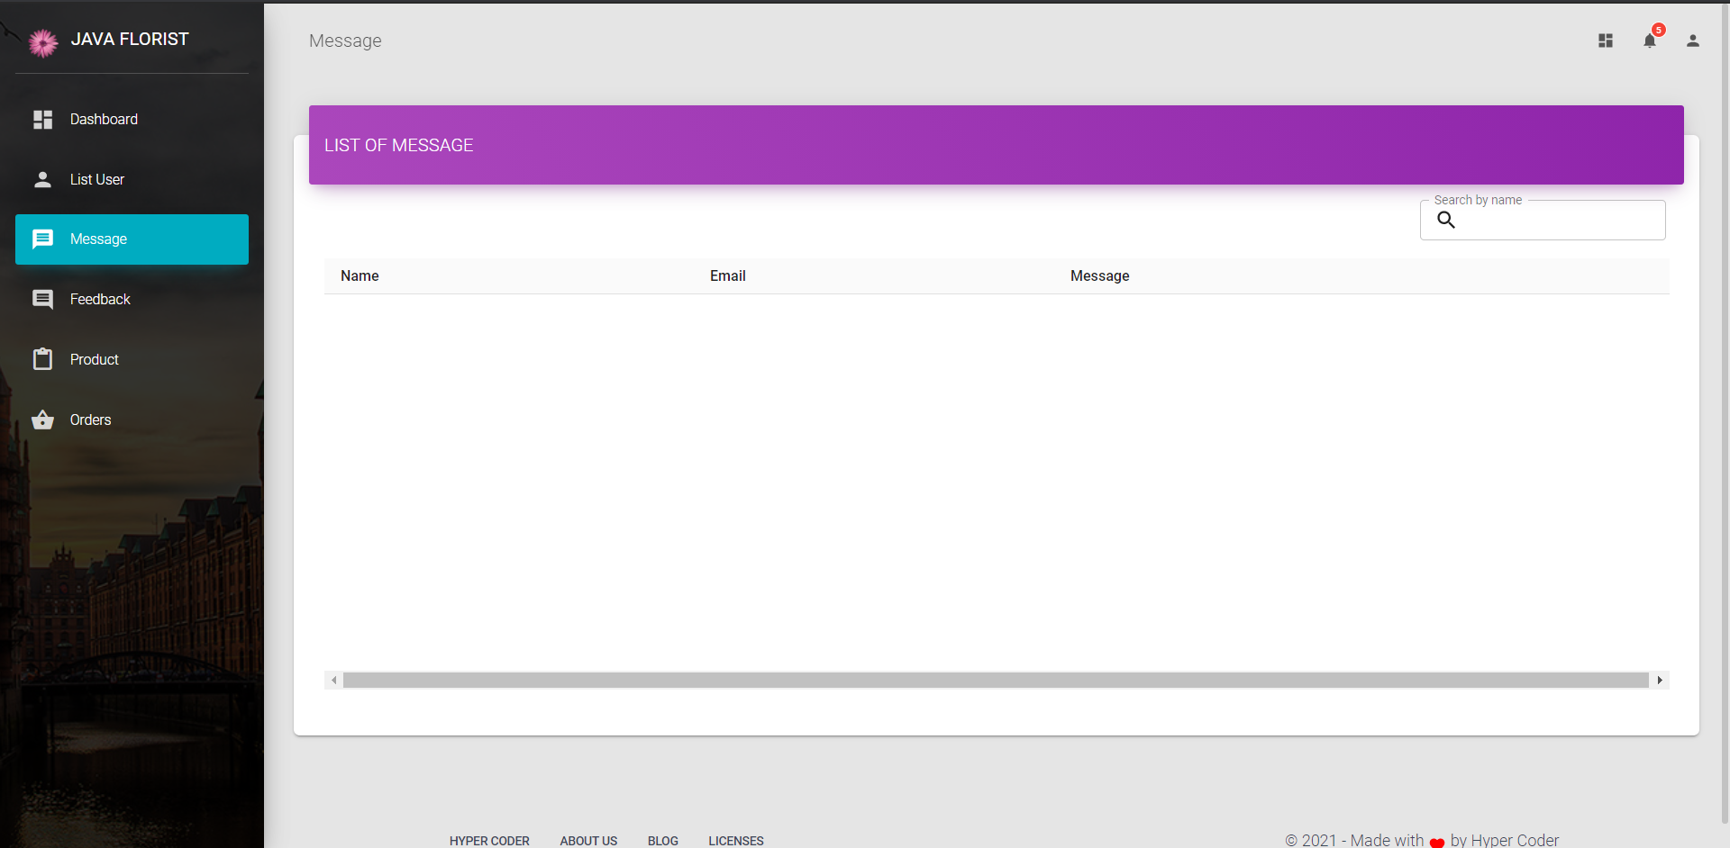

Message administrator can manage viewing message information on this page

# Feedback

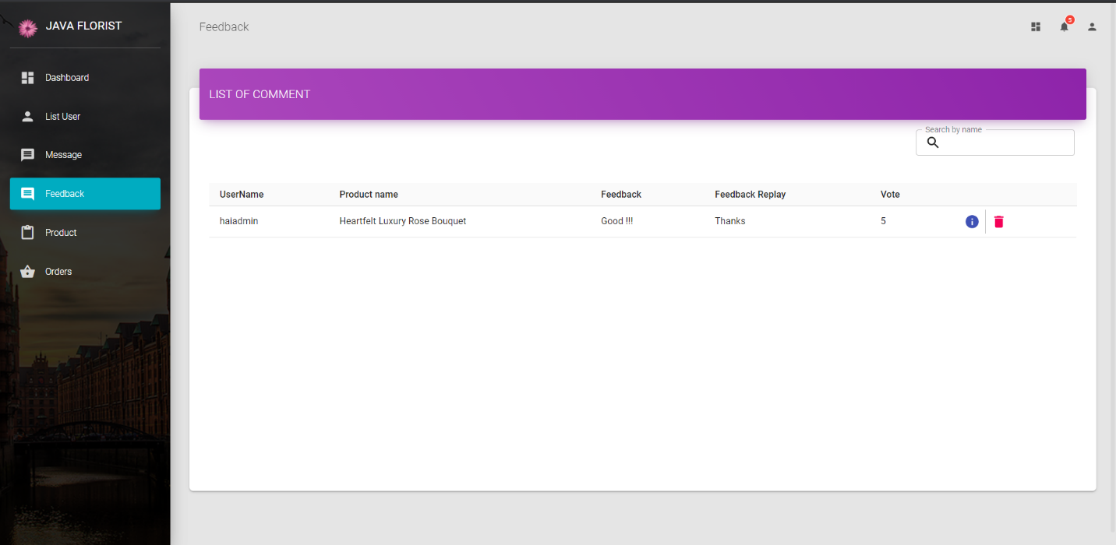

1. Feedback list

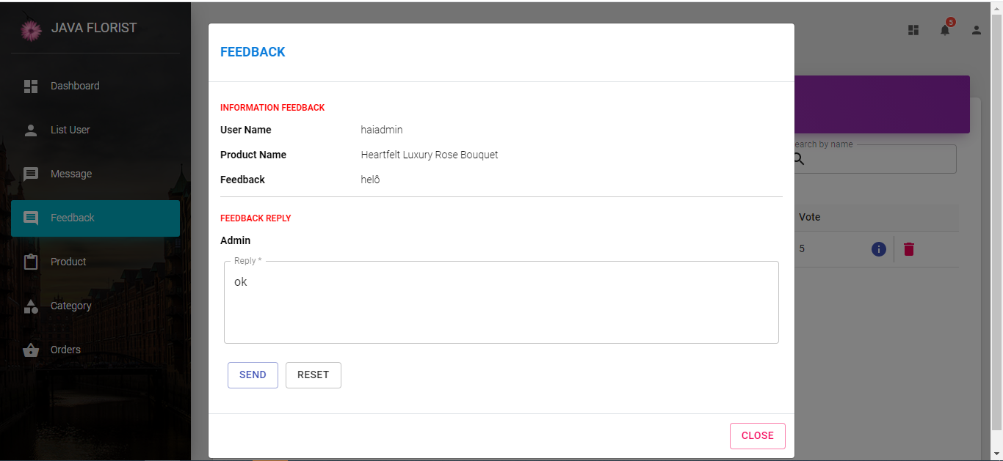

1. Feedback details

**Feedback**: administrator can manage viewing message information, and reply on this page

# Order

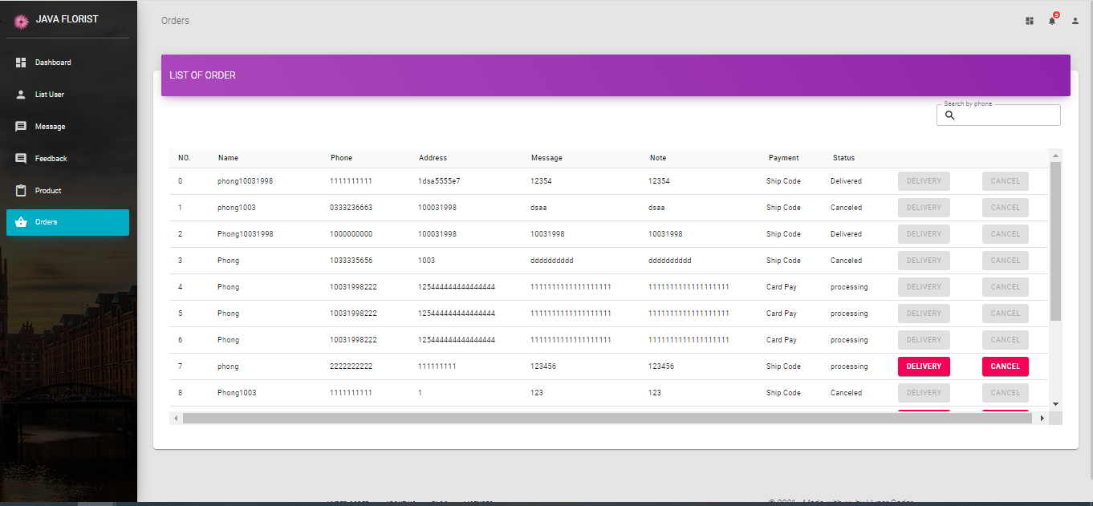

1. Order list

**Admin:** Admin can view order information on this page. You can check order status, delete order and update order status here.